CO3 ASSESSMENT TOOL-2
Case Study: Insurance Claim Processing System (Merge Sort)
Aim
To analyze the application of Merge Sort in an insurance claim processing system for sorting claim records based on submission date and policy priority, ensuring stable and efficient processing for auditing and settlement workflows.
Problem Definition
An insurance company manages thousands of claim records daily.
Each claim contains:
- Claim ID
- Submission Date
- Policy Priority
- Customer Details
- Claim Amount
The records must be sorted for:
• Faster claim settlement
• Auditing processes
• Fraud detection
• Regulatory compliance
• Workflow management

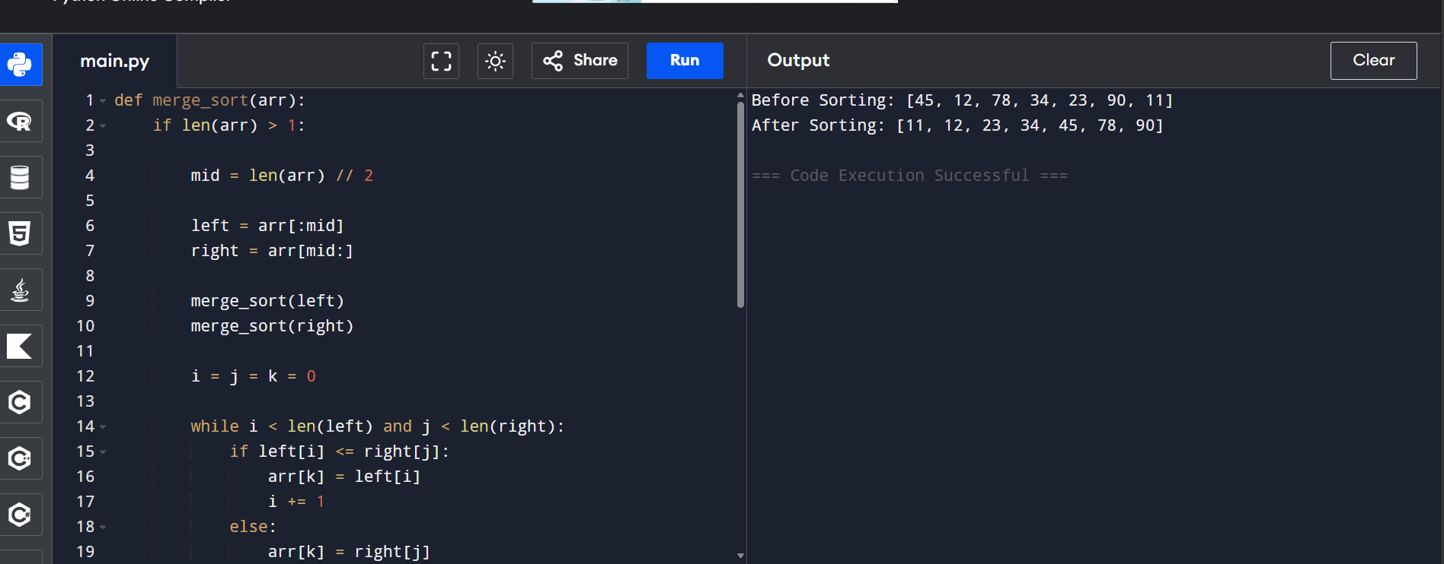

Case Study: Dynamic Ad Placement System (Quick Sort)
Aim
To analyze the application of Quick Sort in a dynamic digital advertising system that ranks advertisements based on bid values and relevance scores, evaluate its efficiency, and justify optimized pivot selection strategies for real-time sorting.
Problem Definition
A digital advertising platform must continuously rank advertisements according to:
- Bid Value
- Relevance Score
- User Preferences
- Click-Through Rate (CTR)
The system should quickly reorder advertisements whenever new bids arrive or relevance scores change.

